ITI – Bash Scripting Lab 3
Mohammad Tarek – Data Management

- Write a script called mycase, using the case utility to checks the type of character entered by a user: a. Upper Case. b. Lower Case. c. Number. d. Nothing.
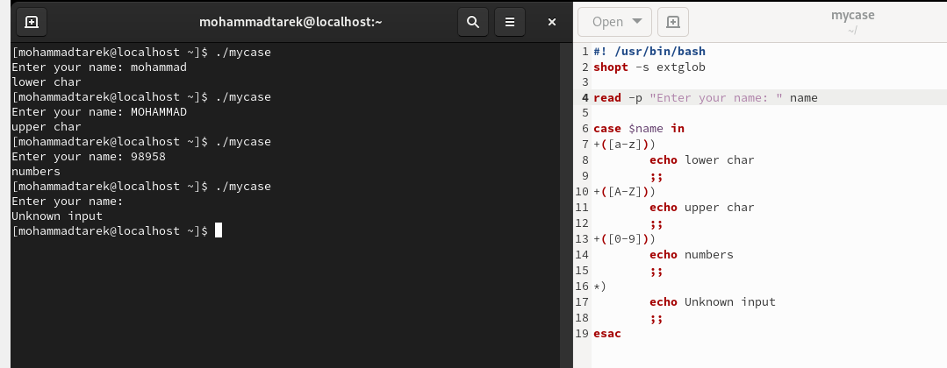
- Enhanced the previous script, by checking the type of string entered by a user: a. Upper Cases. b. Lower Cases. c. Numbers. d. Mix. e. Nothing.
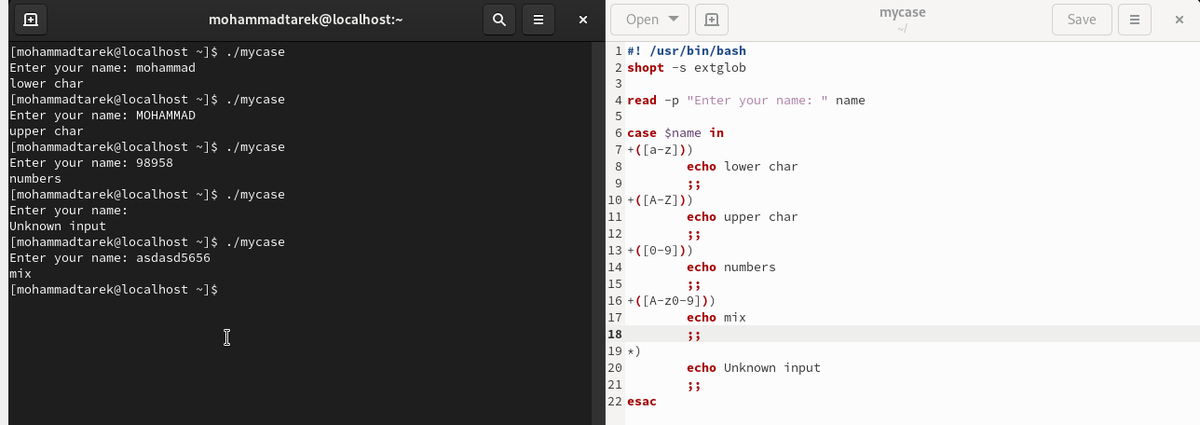
- Write a script called mychmod using for utility to give execute permission to all files and directories in your home directory.
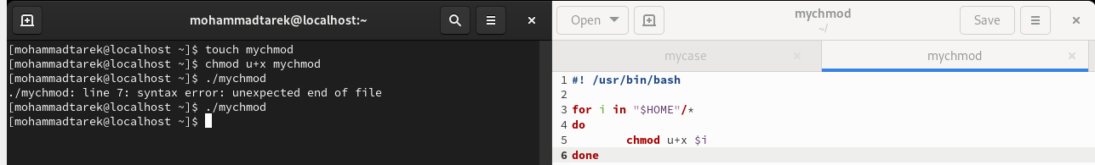
- Write a script called mybackup using for utility to create a backup of only files in your home directory.
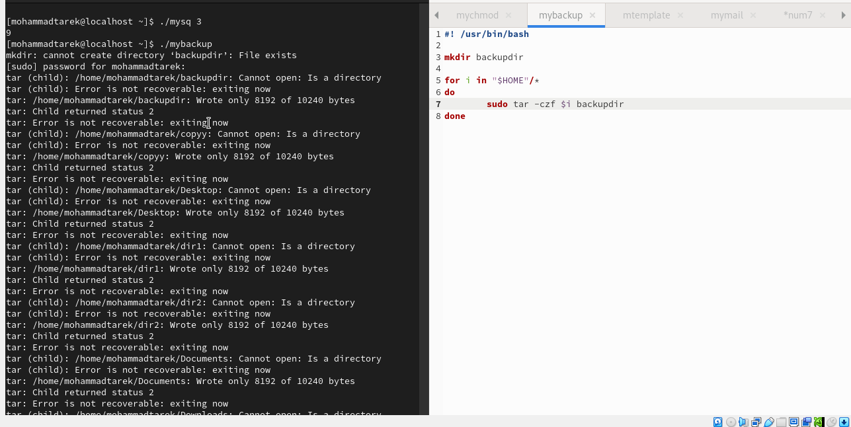
- Write a script called mymail using for utility to send a mail to all users in the system. Note: write the mail body in a file called mtemplate.
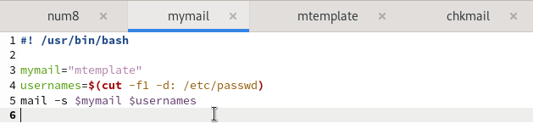
- Write a script called chkmail to check for new mails every 10 seconds. Note: mails are saved in /var/mail/username.
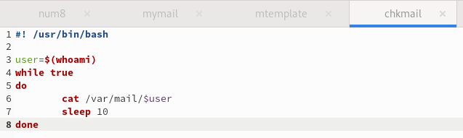
- What is the output of the following script
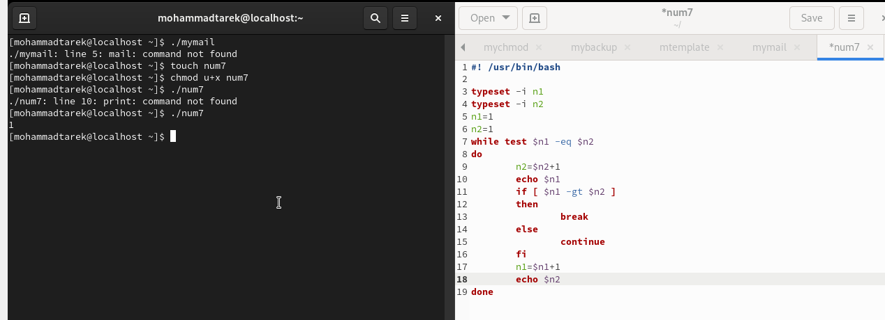

- Create the following menu: a. Press 1 to ls b. Press 2 to ls –a c. Press 3 to exit Using select utility then while utility.
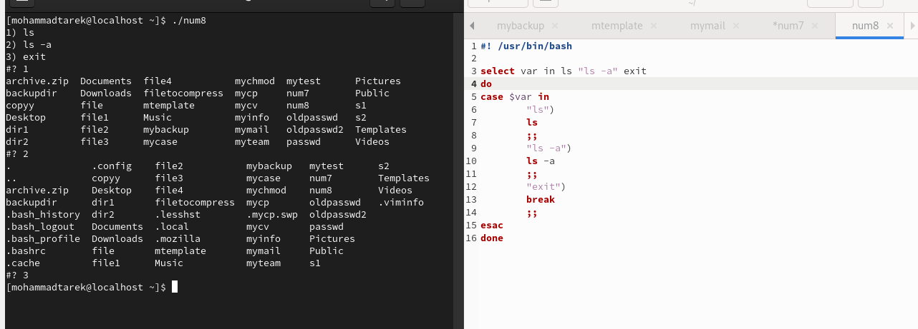
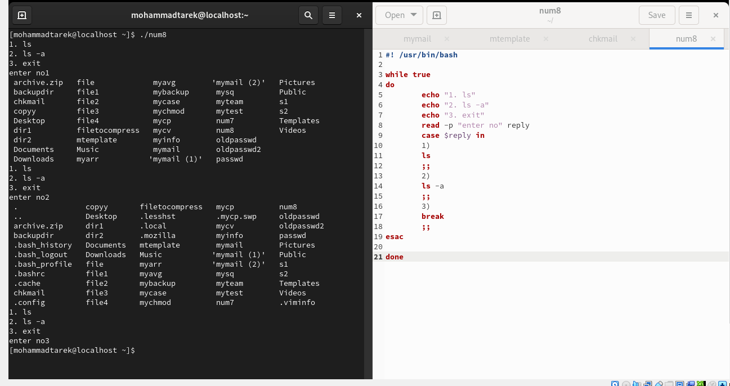
- Write a script called myarr that ask a user how many elements he wants to enter in an array, fill the array and then print it.
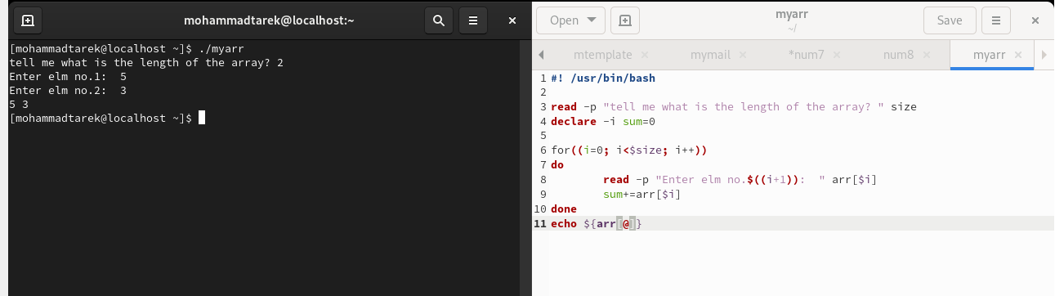
- Write a script called myavg that calculate average of all numbers entered by a user. Note: use arrays
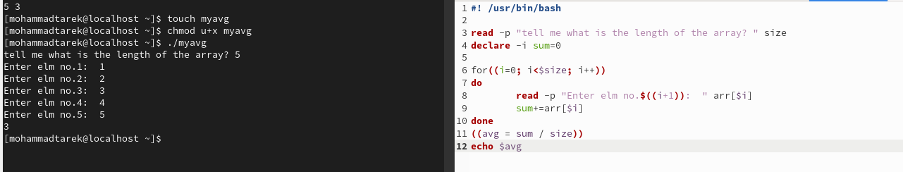
- Write a function called mysq that calculate square if its argument.
